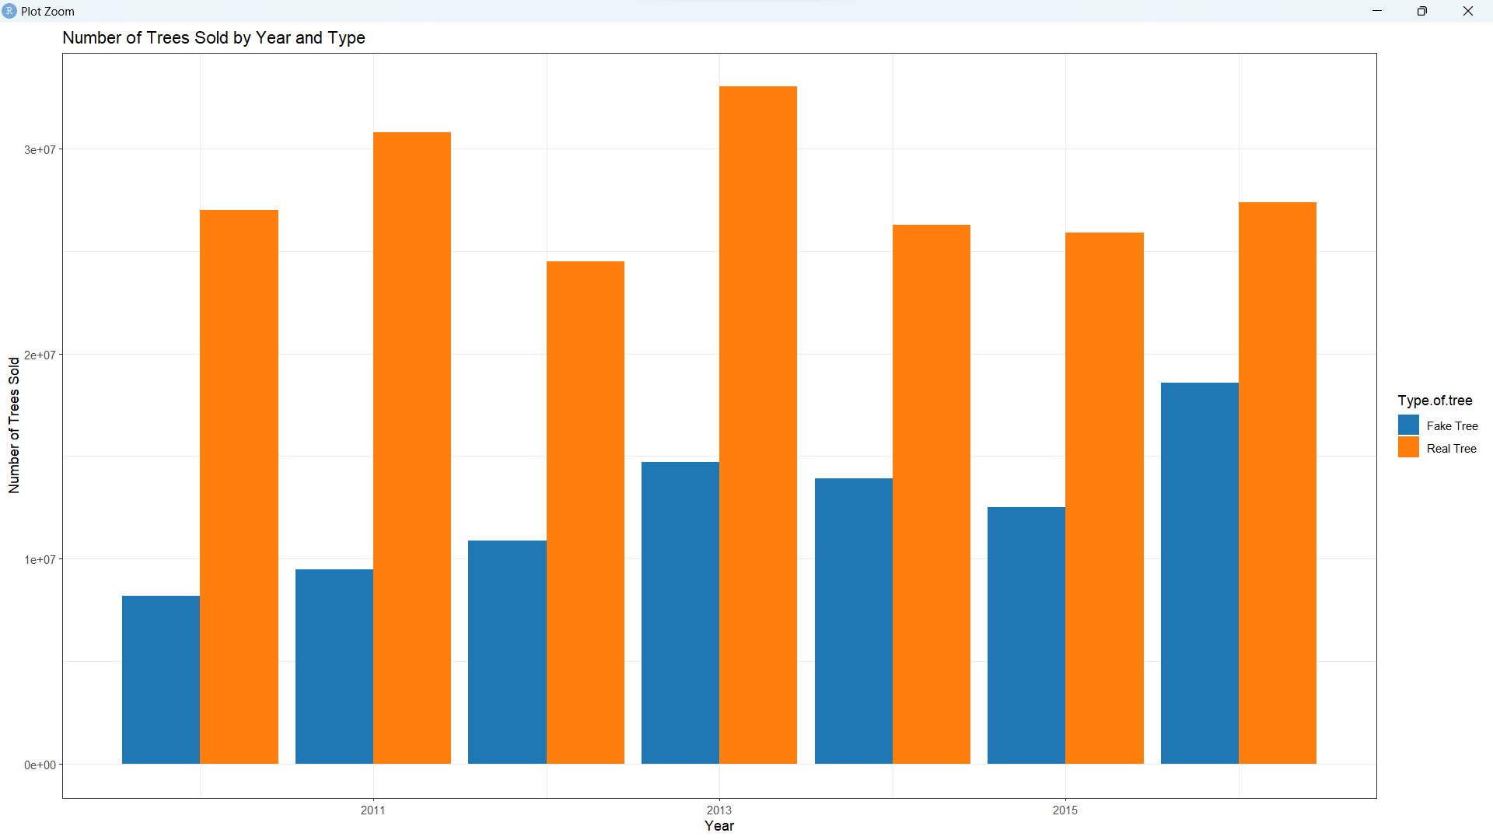Q2



From the bar charts, the number of real trees fluctuates around 27 million. There is no significant uprising or downward trend for the number of real trees, possibly because the demand for real trees has reached a saturation point. However, the number of fake trees is rising significantly, from 8.2 million in 2010, an increase of around 127%, to 18.6 million in 2016.

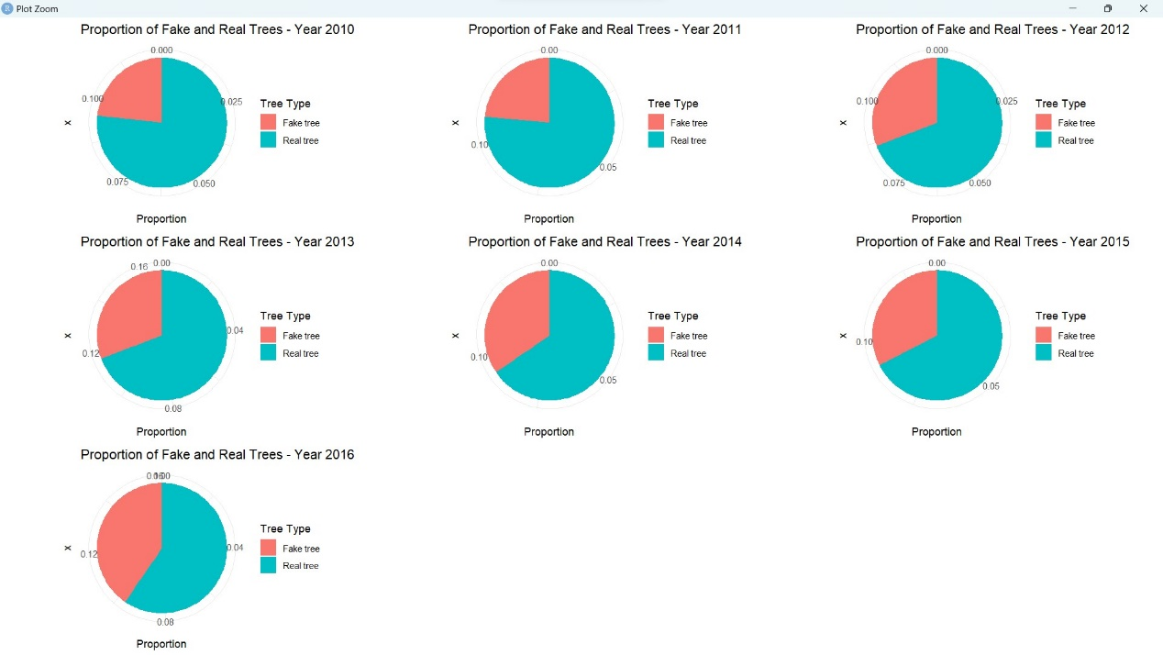(2)

The pie charts show the proportion of fake trees of the entire Christmas trees market is increasing, from around 20% in 2010 to more than 40% in 2016.

Both Figures (1) and (2) can be explained by the increasing popularity of fake trees. It suggests that consumers are more willing to find artificial alternatives since fake Christmas trees are more convenient, cost-effective, and environmentally friendly.

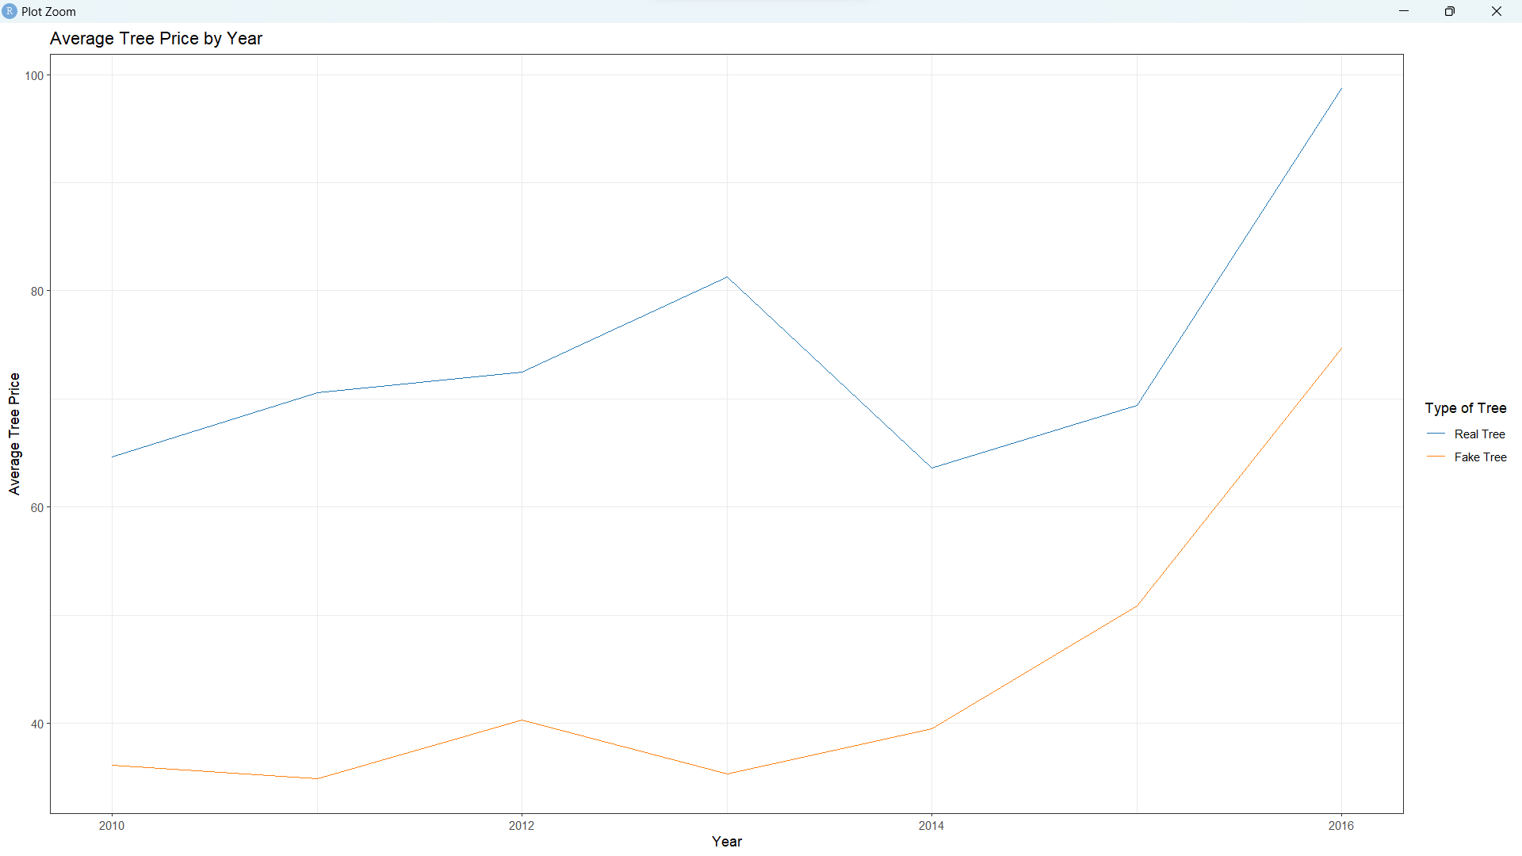(3)

First, from the line graphs, the average price of fake trees is lower than that of real trees. The most probable rationale is that the production cost of fake trees is lower. Real trees require more human resources to take care of and more caution while transporting. Moreover, fake tree prices grow quickly in the later years, and its cause may be that society is pursuing a greener environment. Thus, a higher demand will lead to high average fake tree prices.

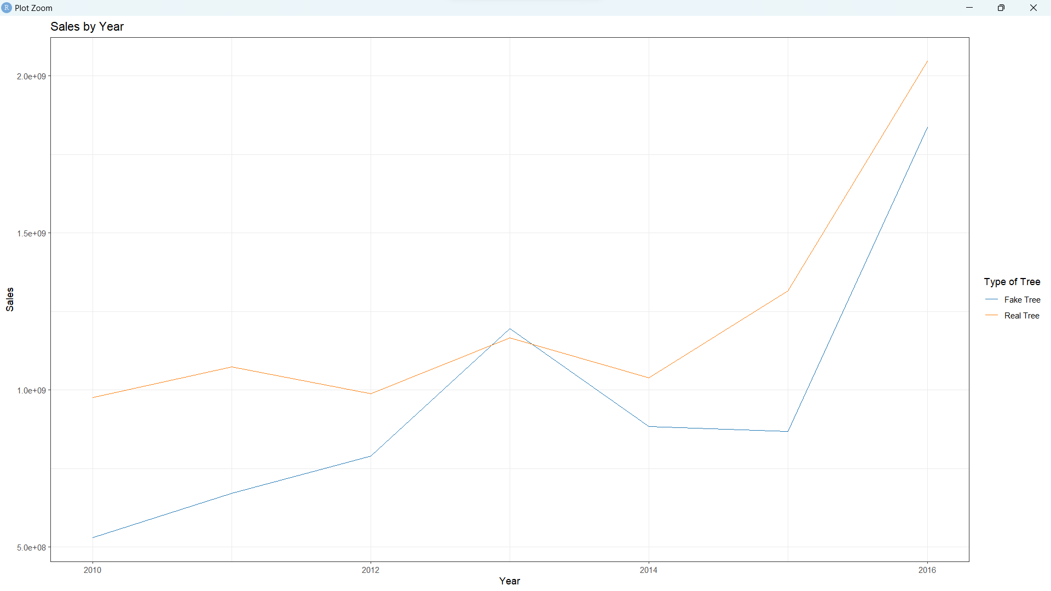(4)

From another line graph plotted by year against sales, the sales of fake and real trees are rising. Figures (3) and (4) show increasing demands and sales of fake and real trees. It may thus indicate that the society is experiencing general economic growth, in which people have more wealth than before, so more people are more willing to purchase Christmas trees for celebration.

(4)

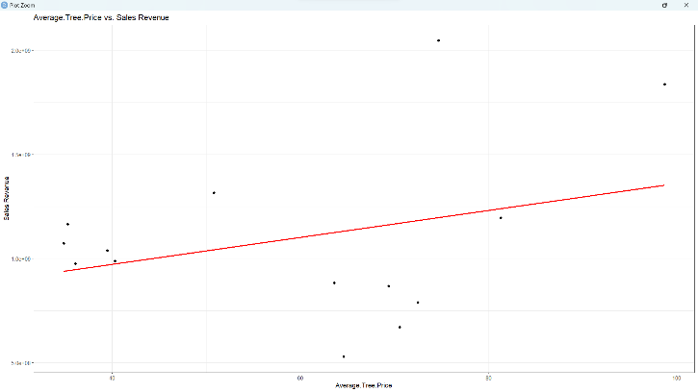

The graph on the left shows the correlation between the number of trees sold and the sales revenue, while the right one demonstrates the correlation between the average tree price and the sales revenue. By calculation in R, the former correlation equals 0.4947227, while the latter is 0.3126897. It implies that the correlation between the number of trees sold and sales revenue is more robust than price. Hence, if sellers want to generate higher profits, they should improve the quantity sold through promotion and advertising instead of direct markup.

Data Source:

<https://www.kaggle.com/datasets/thedevastator/us-christmas-tree-sales-data/data>